**Exercise 3: Stored Procedures**

**Database Setup**

To implement the following scenarios, I first created the required tables accounts and employees using PL/SQL and inserted sample data. These tables include fields such as account_id, account_type, balance, employee_id, department_id, and salary, which are used in the PL/SQL procedures below.

**Attached Tables:**

* **accounts_table_output.csv**

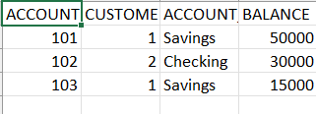

* **employees_table_output.csv**

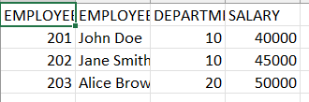

**Scenario 1: Monthly Interest for Savings Accounts**

Question: Write a stored procedure ProcessMonthlyInterest that calculates and updates the balance of all savings accounts by applying an interest rate of 1% to the current balance.

CREATE OR REPLACE PROCEDURE ProcessMonthlyInterest IS

BEGIN

UPDATE accounts

SET balance = balance + (balance * 0.01)

WHERE account_type = 'Savings';

DBMS_OUTPUT.PUT_LINE('Monthly interest applied to all savings accounts.');

END;

/

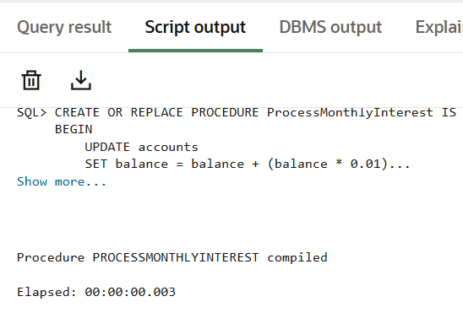

**Scenario 2: Employee Bonus Based on Performance**

Question: Write a stored procedure UpdateEmployeeBonus that updates the salary of employees in a given department by adding a bonus percentage passed as a parameter.

CREATE OR REPLACE PROCEDURE UpdateEmployeeBonus (

p_department_id IN employees.department_id%TYPE,

p_bonus_percent IN NUMBER

) IS

BEGIN

UPDATE employees

SET salary = salary + (salary * (p_bonus_percent / 100))

WHERE department_id = p_department_id;

DBMS_OUTPUT.PUT_LINE('Bonus applied to department ID: ' || p_department_id);

END;

/

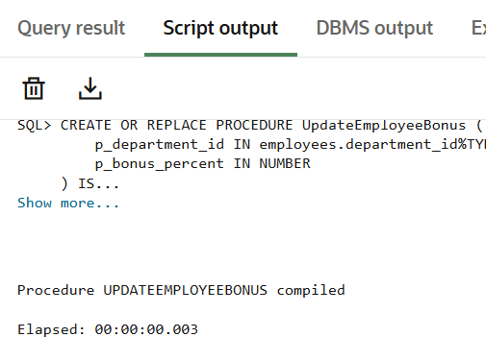

**Scenario 3: Fund Transfer Between Accounts**

Question: Write a stored procedure TransferFunds that transfers a specified amount from one account to another, checking that the source account has sufficient balance before making the transfer.

CREATE OR REPLACE PROCEDURE TransferFunds (

p_from_account IN accounts.account_id%TYPE,

p_to_account IN accounts.account_id%TYPE,

p_amount IN NUMBER

) IS

v_balance NUMBER;

BEGIN

SELECT balance INTO v_balance

FROM accounts

WHERE account_id = p_from_account;

IF v_balance < p_amount THEN

RAISE_APPLICATION_ERROR(-20001, 'Insufficient balance in source account.');

ELSE

UPDATE accounts

SET balance = balance - p_amount

WHERE account_id = p_from_account;

UPDATE accounts

SET balance = balance + p_amount

WHERE account_id = p_to_account;

DBMS_OUTPUT.PUT_LINE('₹' || p_amount || ' transferred from Account ' || p_from_account || ' to Account ' || p_to_account);

END IF;

END;

/

